Task 1

From the brief I was able to highlight the requirements of the client, I selected a several keywords such as:

* “musician”
* “portfolio”
* “store”
* “genres”

These keywords helped me narrow down my research and also helped visualise my design. For my research, I looked into the age group of those who use streaming services and the most popular genres within those age groups.

I began by visiting the websites for some of my favourite bands and artist and from my findings, there is a common theme that runs through all of them - minimalism.

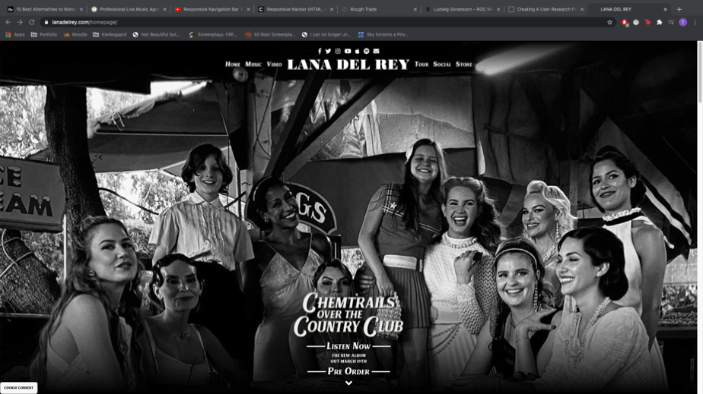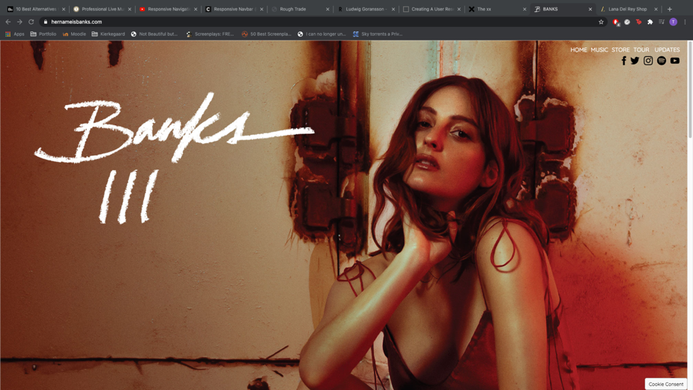Banks’ website is a good example of this minimalism, the amount of text on the page is limited six words, five of them being used for the navigation bar similarly with another one of my favourite artists - Lana Del Rey’s website.

However, unlike Banks’ home page, Lana Del Rey’s page relatively has more text but the ‘less is more’ ideology is still very apparent.

The similarities are also very clear when we land on both pages, they’re both covered with a large promotional picture. The images that cover both homepages are promoting the artists latest release which then serve the bases for the colour of the house style for the other pages. We can see the same colour schemes from both Banks and Lana Del Rey’s promotion artwork spill unto their merchandise pages.

On the merchandise page, the similarities continue both artist websites shared and that’s the 3x3 grid display of the merchandises they sell. The simple layout resembles those of actual ecommerce websites such as ASOS and Carhartt which are the standards for an online store and aesthetically pleasing.

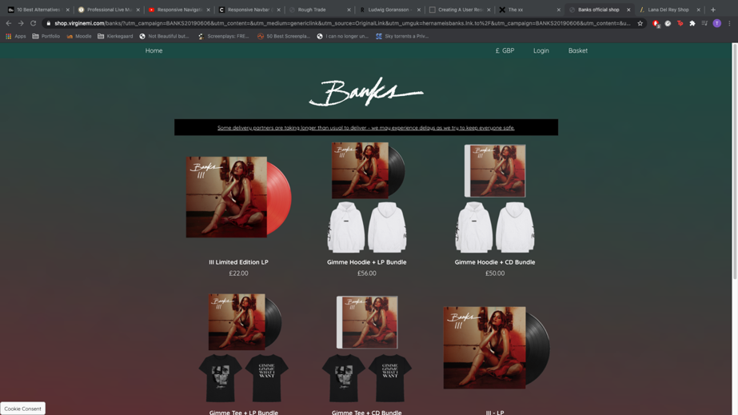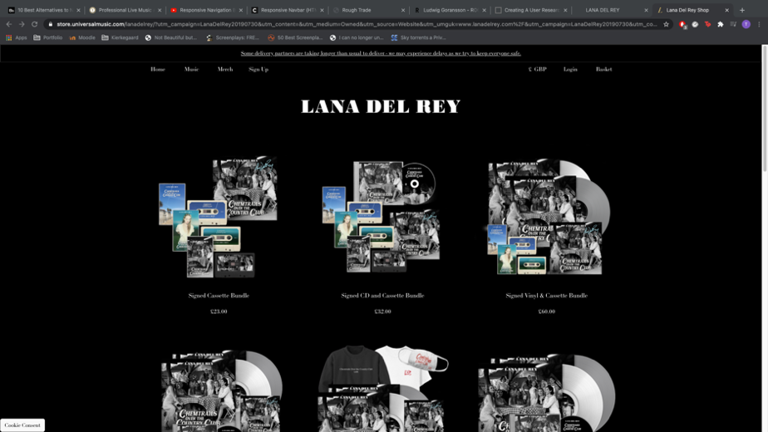

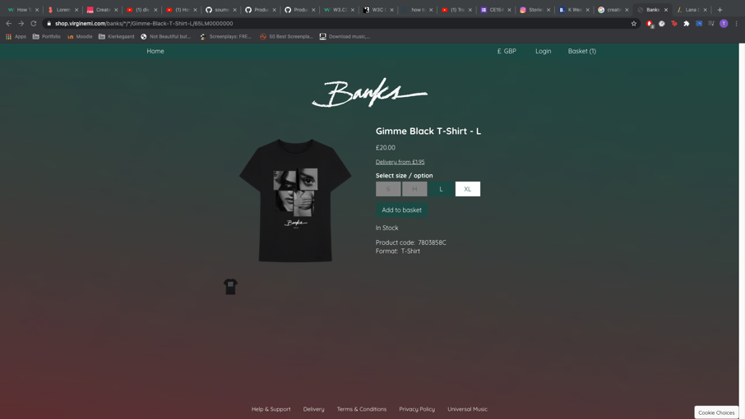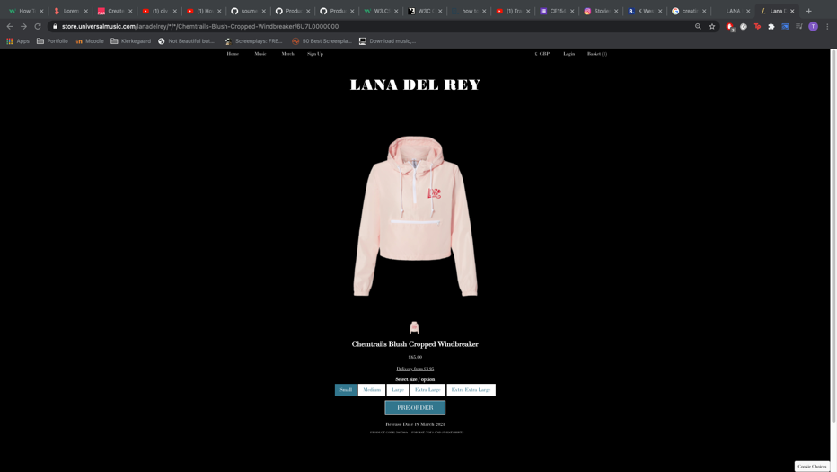When a merchandise is clicked, we are transported to the merchandise description page which is where both websites begin to differ. Although both pages keep the same colour scheme as the previous page the layout of both merchandise descriptions are dissimilar; whilst Banks’ page displays the description horizontally, Reys is vertical which isn’t as visually please as the former.

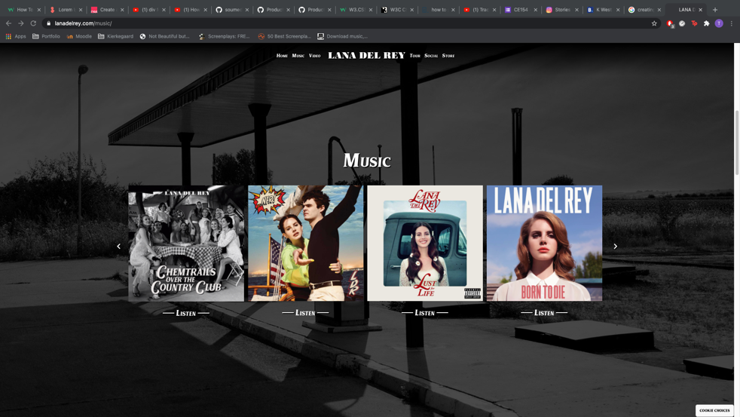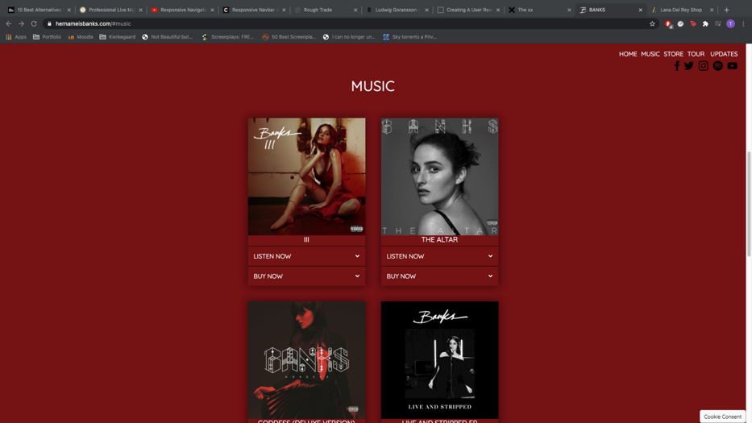The disimilarities continues onto the music page, a page which aims to inform the user about the records by the artist, both still using the colour scheme from the homepage and use the album artwork as hyperlinks to the artist streaming services profiles.

One thing I got from the brief was the basket page, however, both Banks’ and Lana Del Rey do not have such page, what they both shared was a drop-down basket. To get some inspiration for the basket page, I did some further research and landed the band Bombay Bicycle Club – all the similarities with both Banks and Del Rey’s websites are evident from the home page through to the music page.

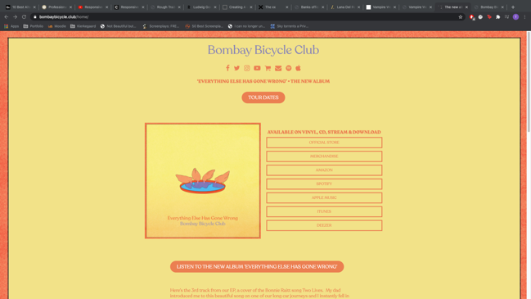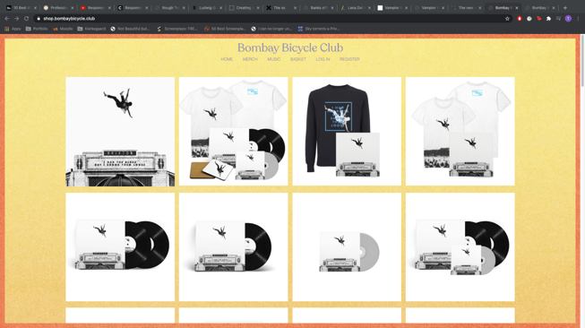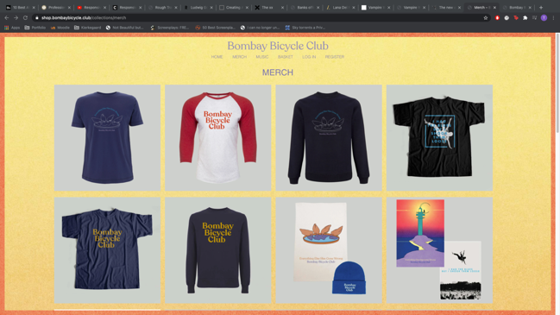

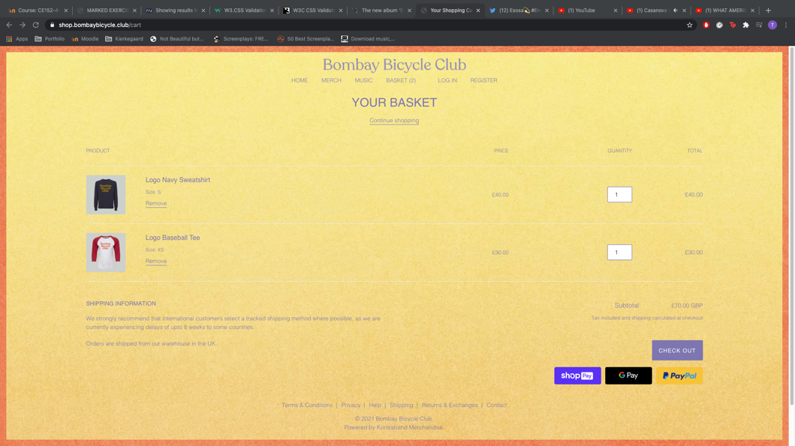However, unlike the previous websites the bands’ website includes a basket page, a simple but effective layout with thumbnails of the merchandise being bought.

Task 2

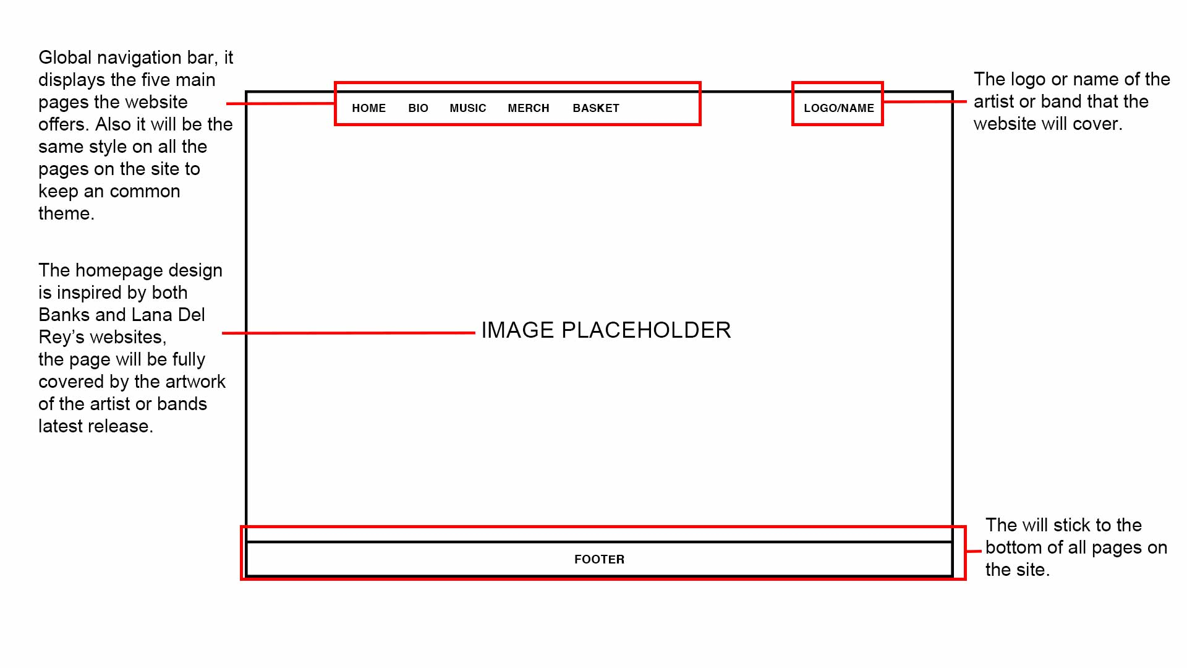

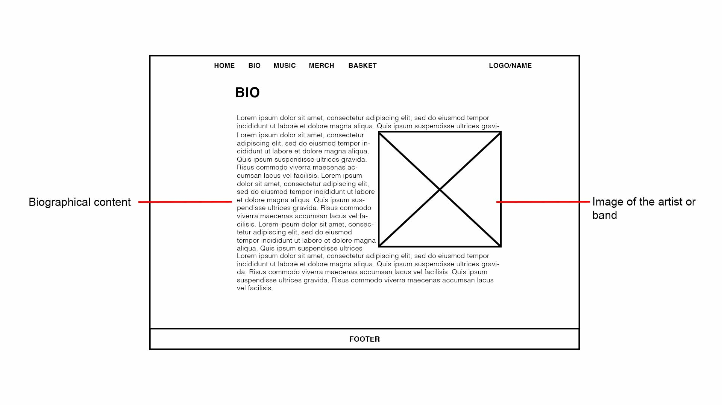

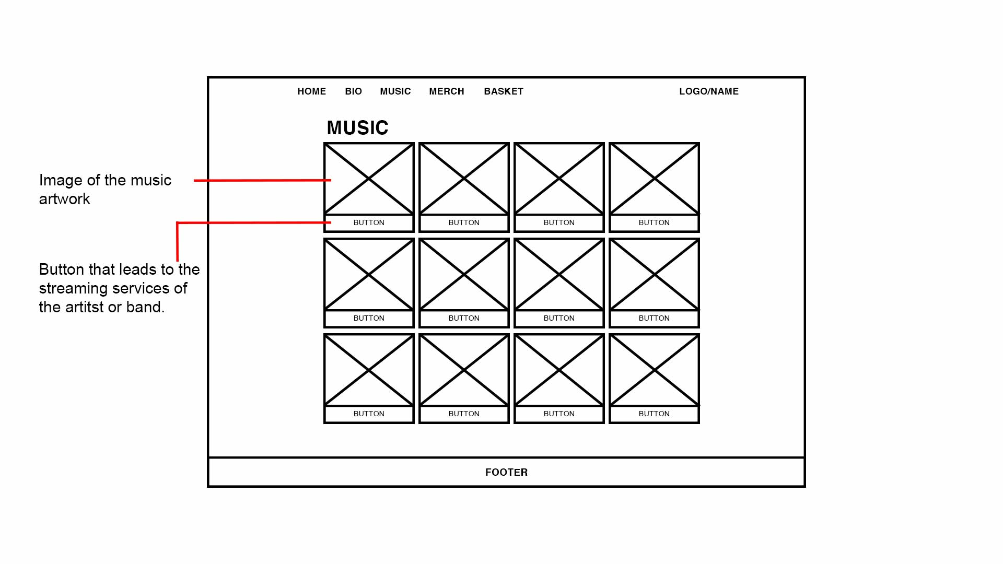

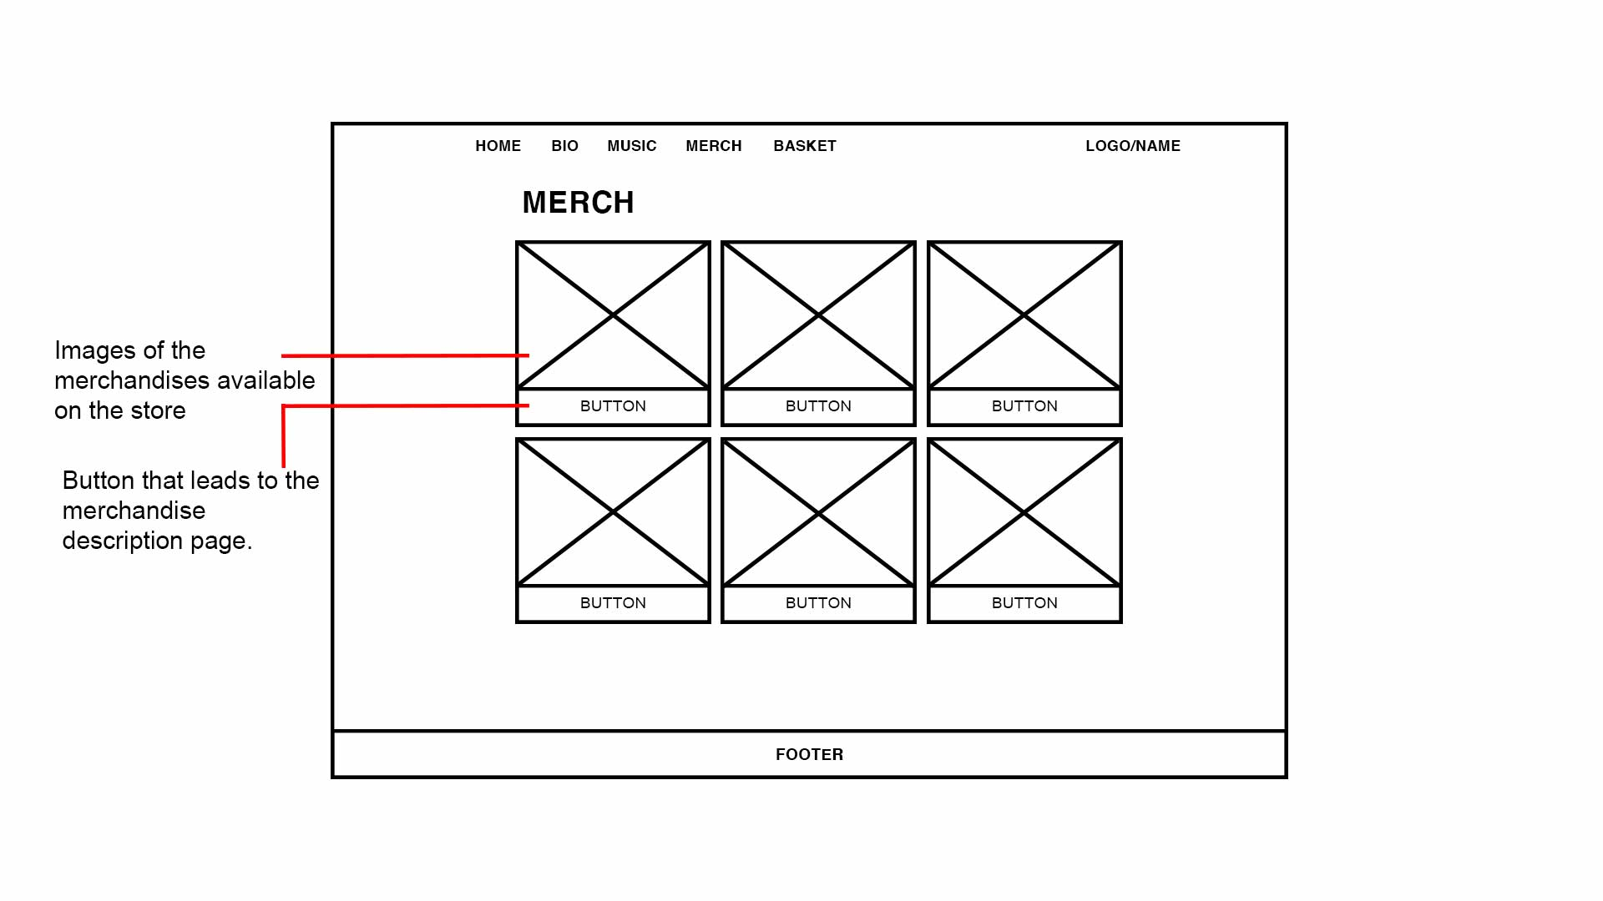

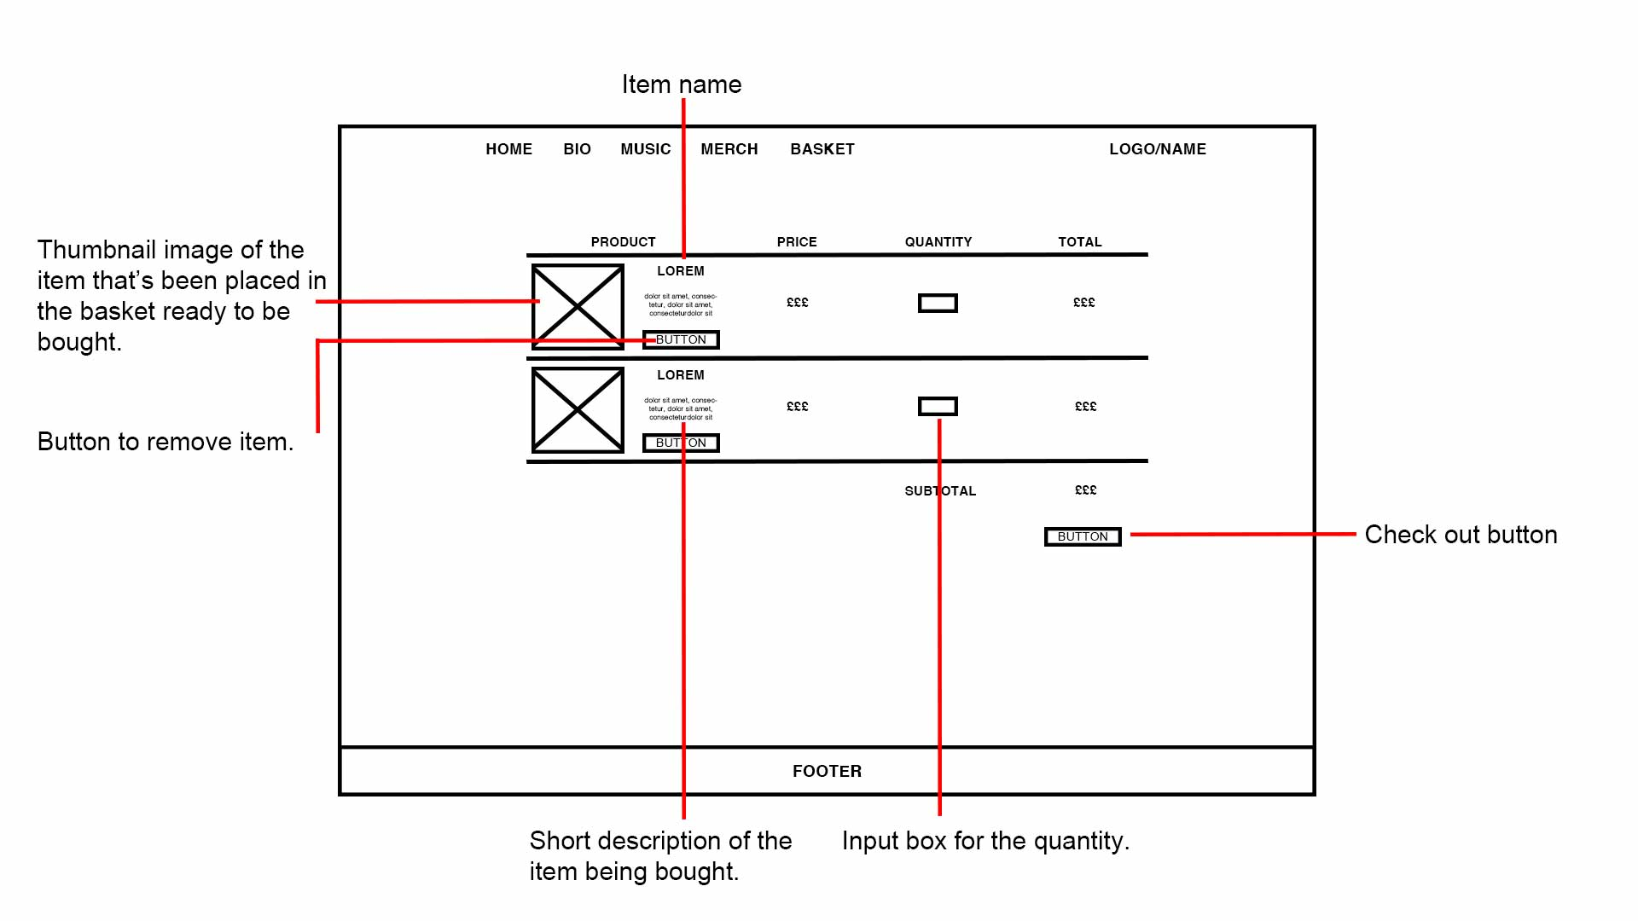

The design is very influenced by the websites I researched; the layouts seem to be the standard for music portfolio websites. The artist I decided to design for is Toro Y Moi, an indie rock artist similar to BANKS and Lana Del Rey. With an artist like Toro, who has distinct and unique imagery, I was easy to create house style or theme from his profile.

I used his latest release as the basis of the theme for the whole site.

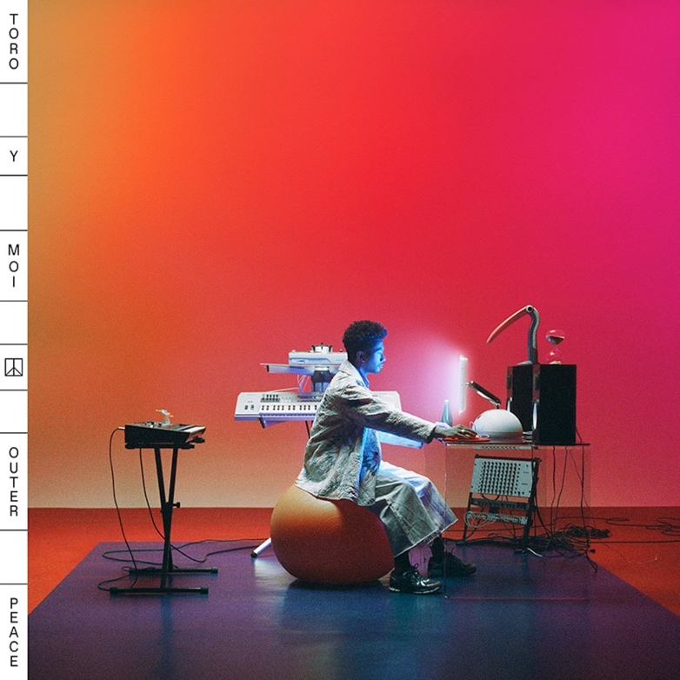The font used throughout the website is inspired by the one used on the artwork. The colours that run on all the pages were also lifted from the cover artwork to provide a house style similar to both BANKS and Lana Del Rey’s sites.

Task 3

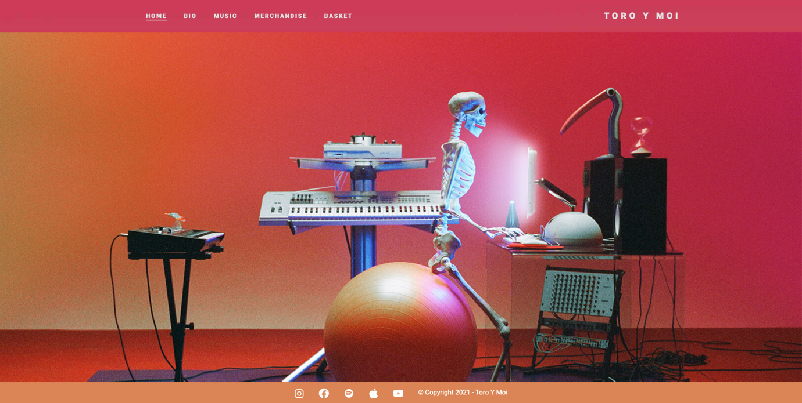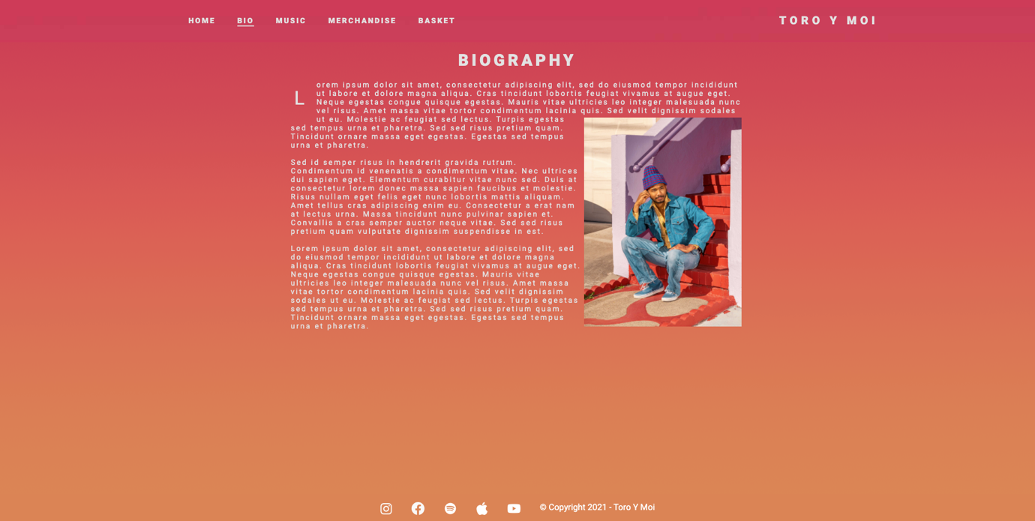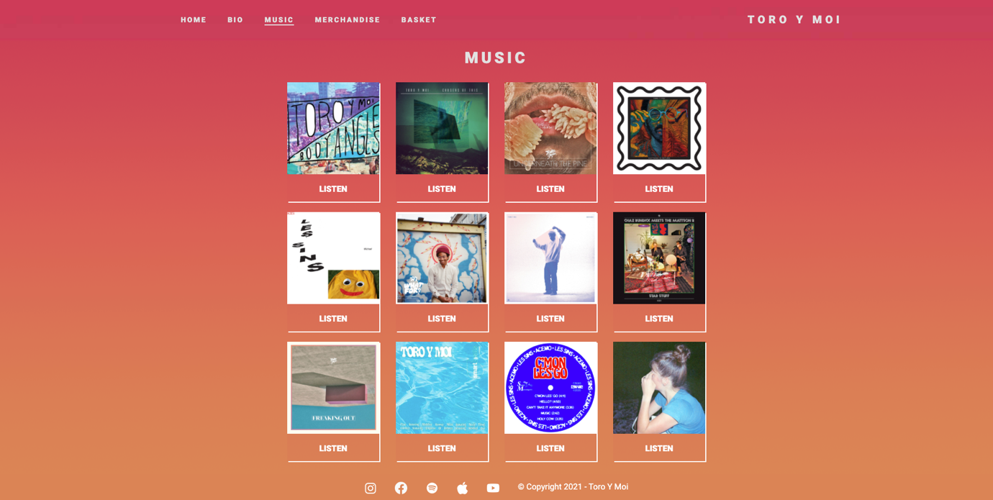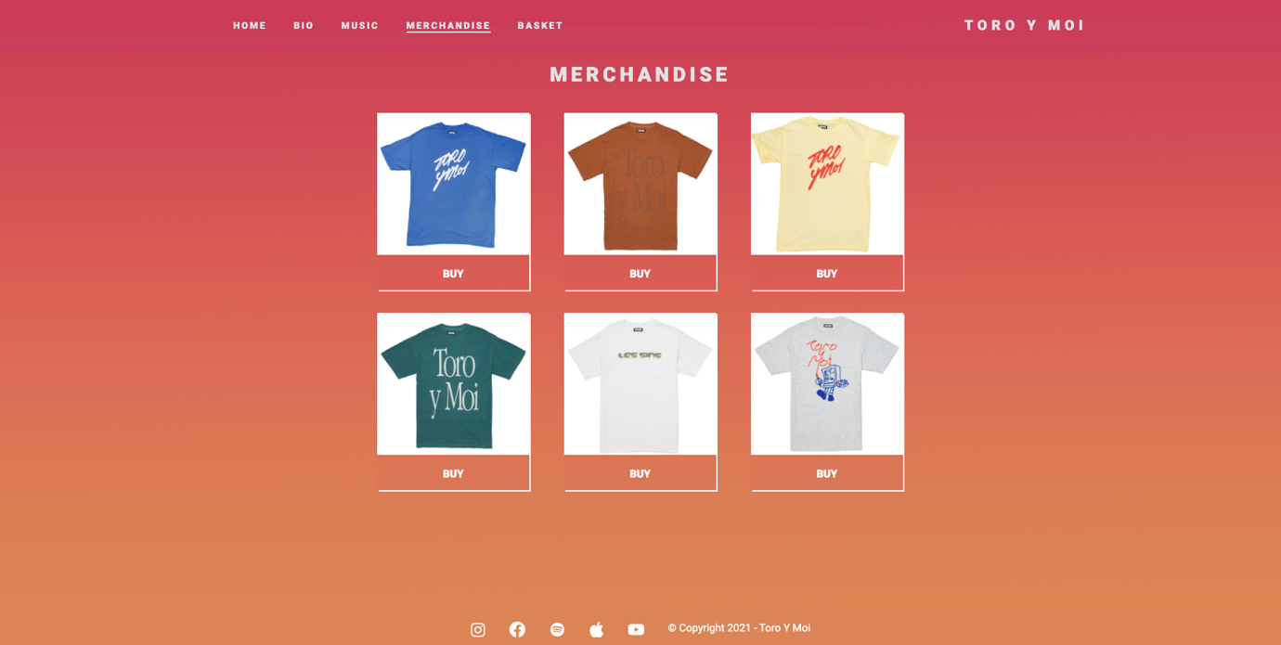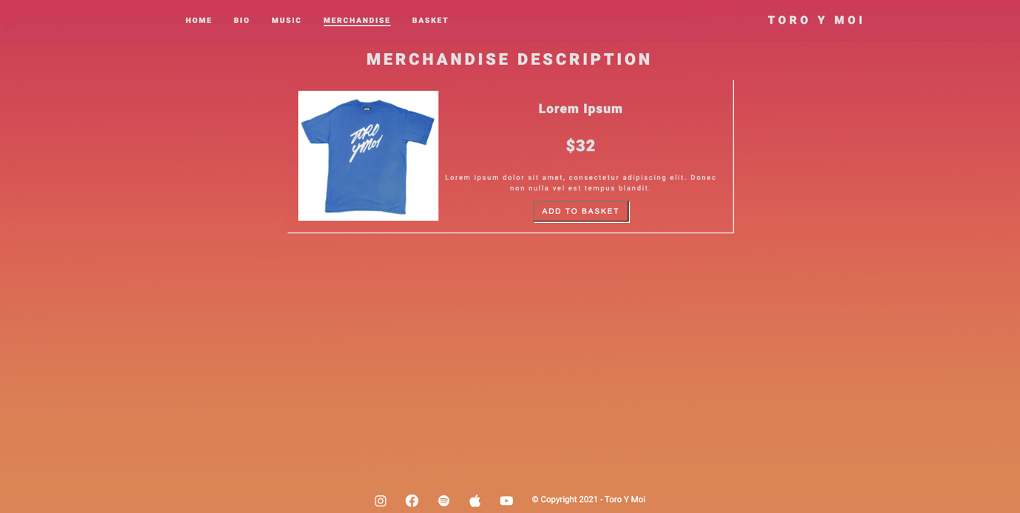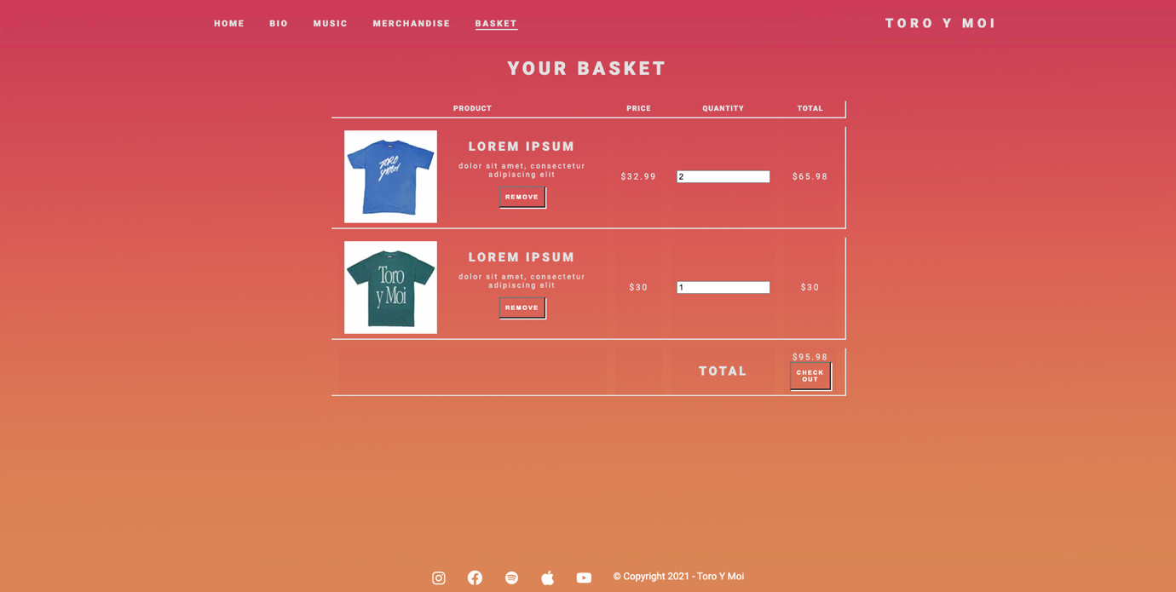

Task 4

4.1

To gather feedback and opinions, I presented my site to some of potential users and then asked then to fill form on questions about the site. I decided to use a number scale for the answers to gauge the general feeling of the website. I asked questions such as:

* How visually appealing is the site?
* Does the site have friendly user interface?
* How easy is it to understand the information on the site?
* How easy was it to navigate through the website?
* How well does the site meet the requirements?
* How would you rate your experience on the site?

and finally, suggestions on how the website could be improved.

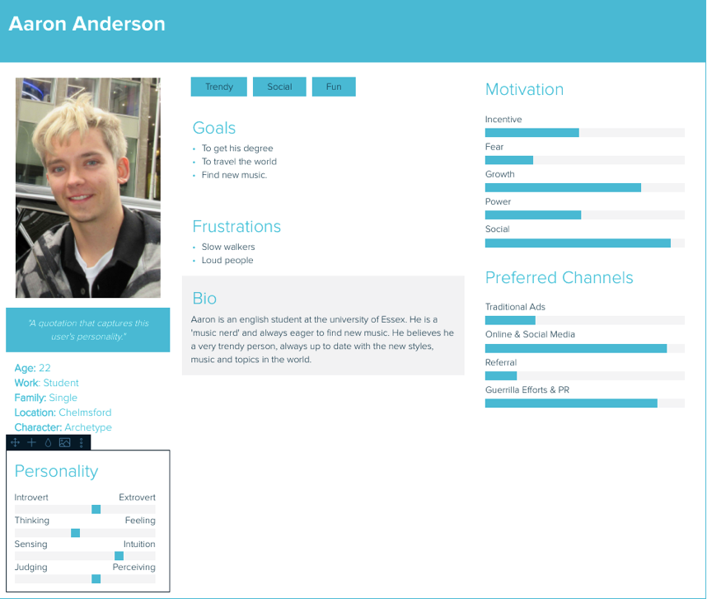

These are some personas I created, based upon my research I believe these characters a great representative of the demographic who would visit the website and would appreciate the design.

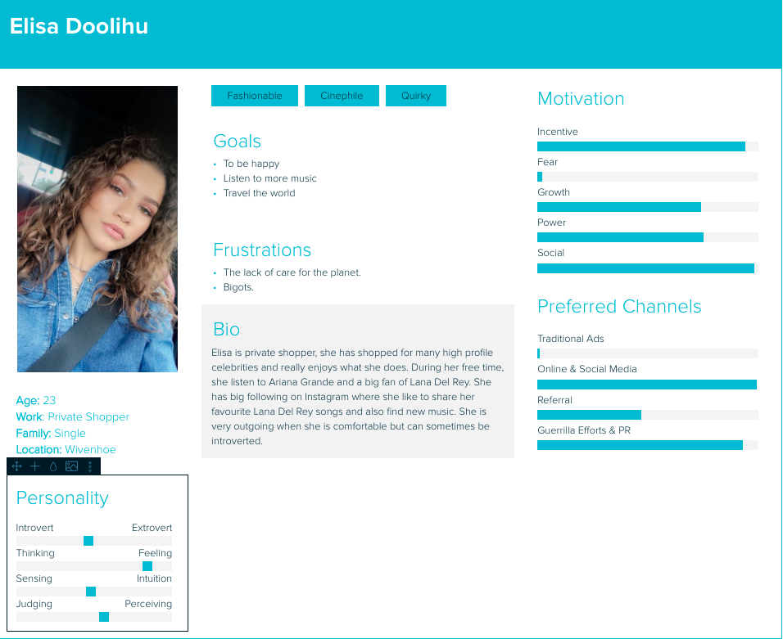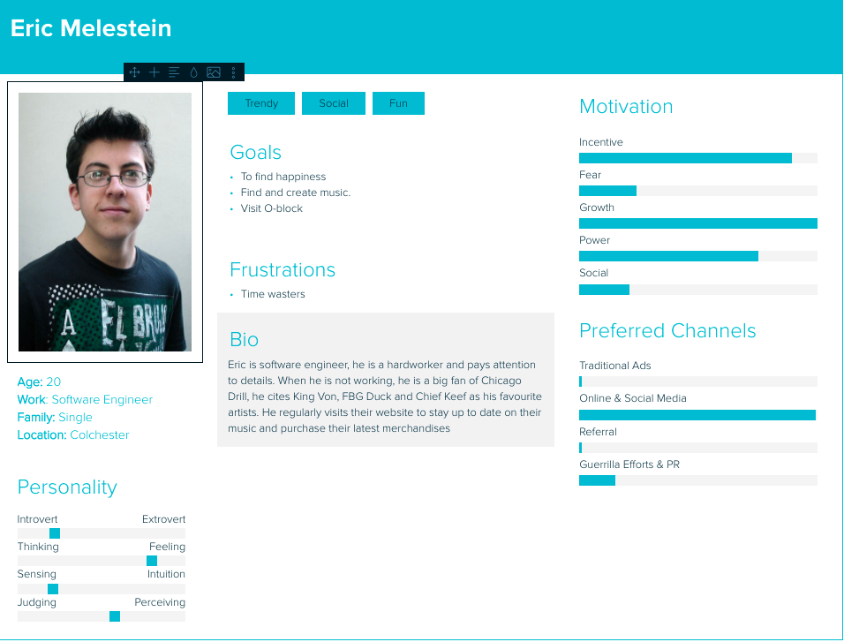

From my findings, it is clear that many found the website visually pleasing, the ratings for the friendliness of the user interface were high, many found it easy to navigate through website and believe the website meets the requirements. However, there’s a split when rating how easy it is to understand the information on the site, it was suggested that the text could have been better for readability. Another suggestion was to use more space.

4.2

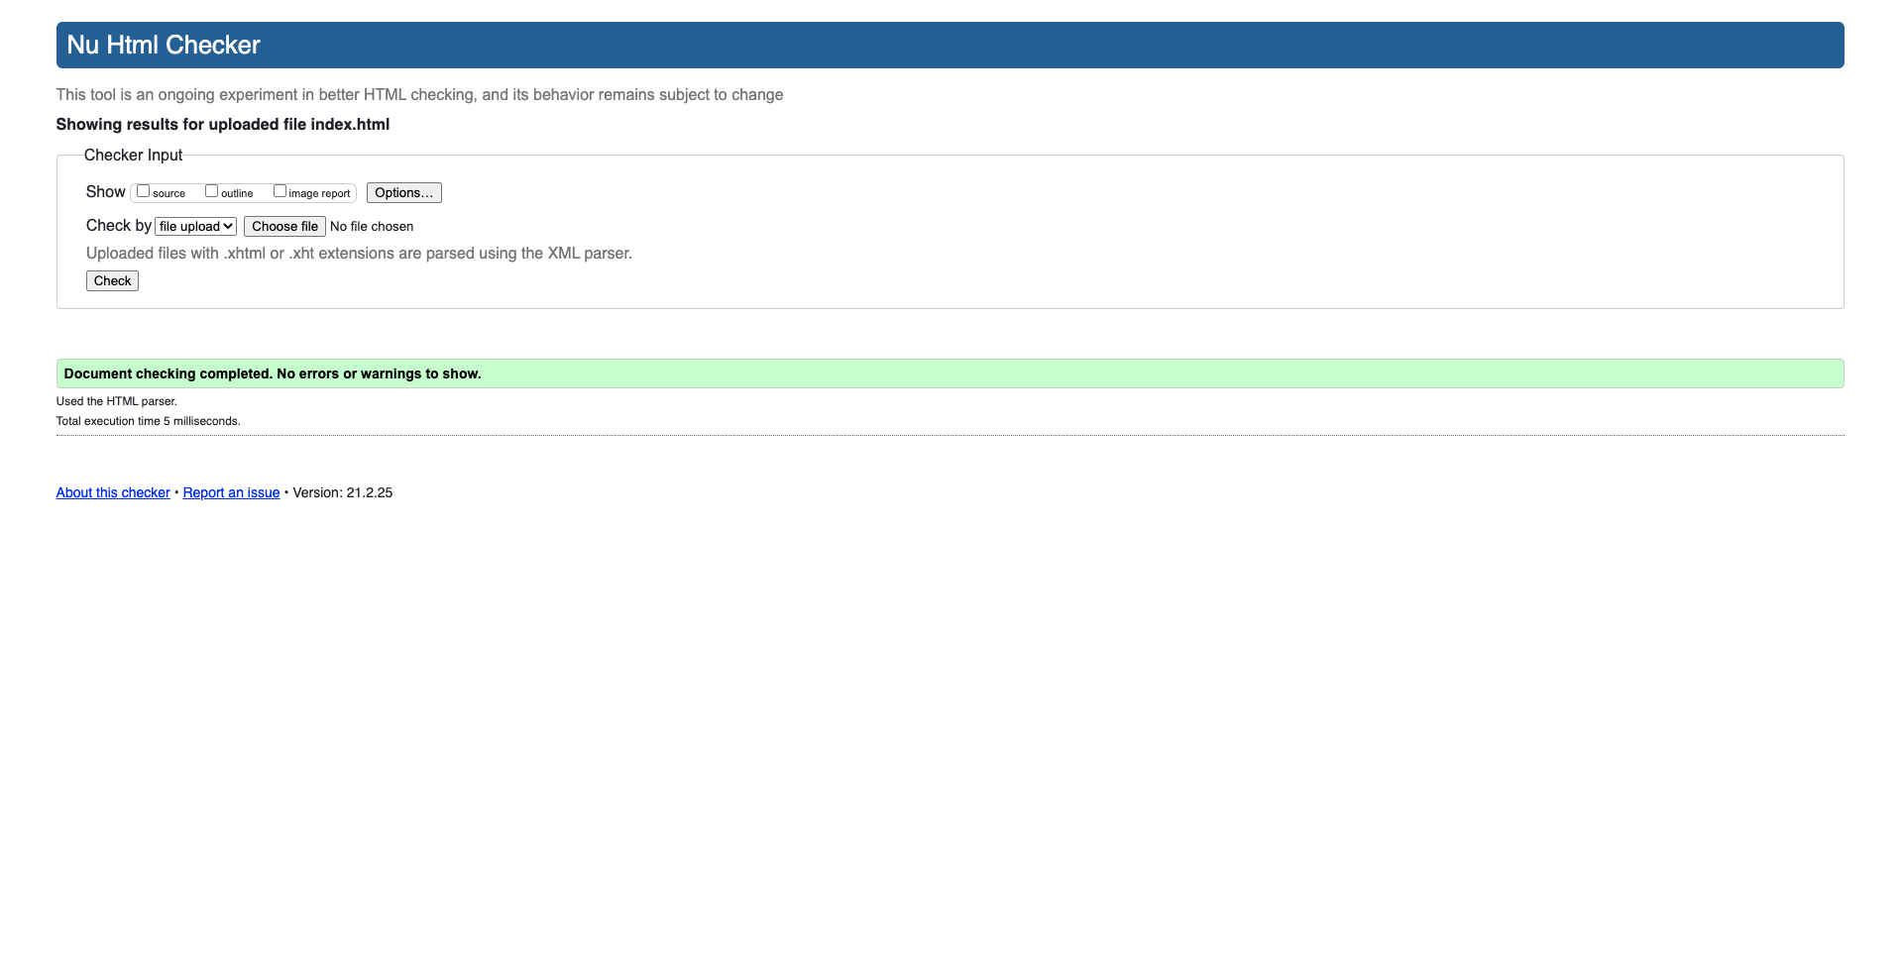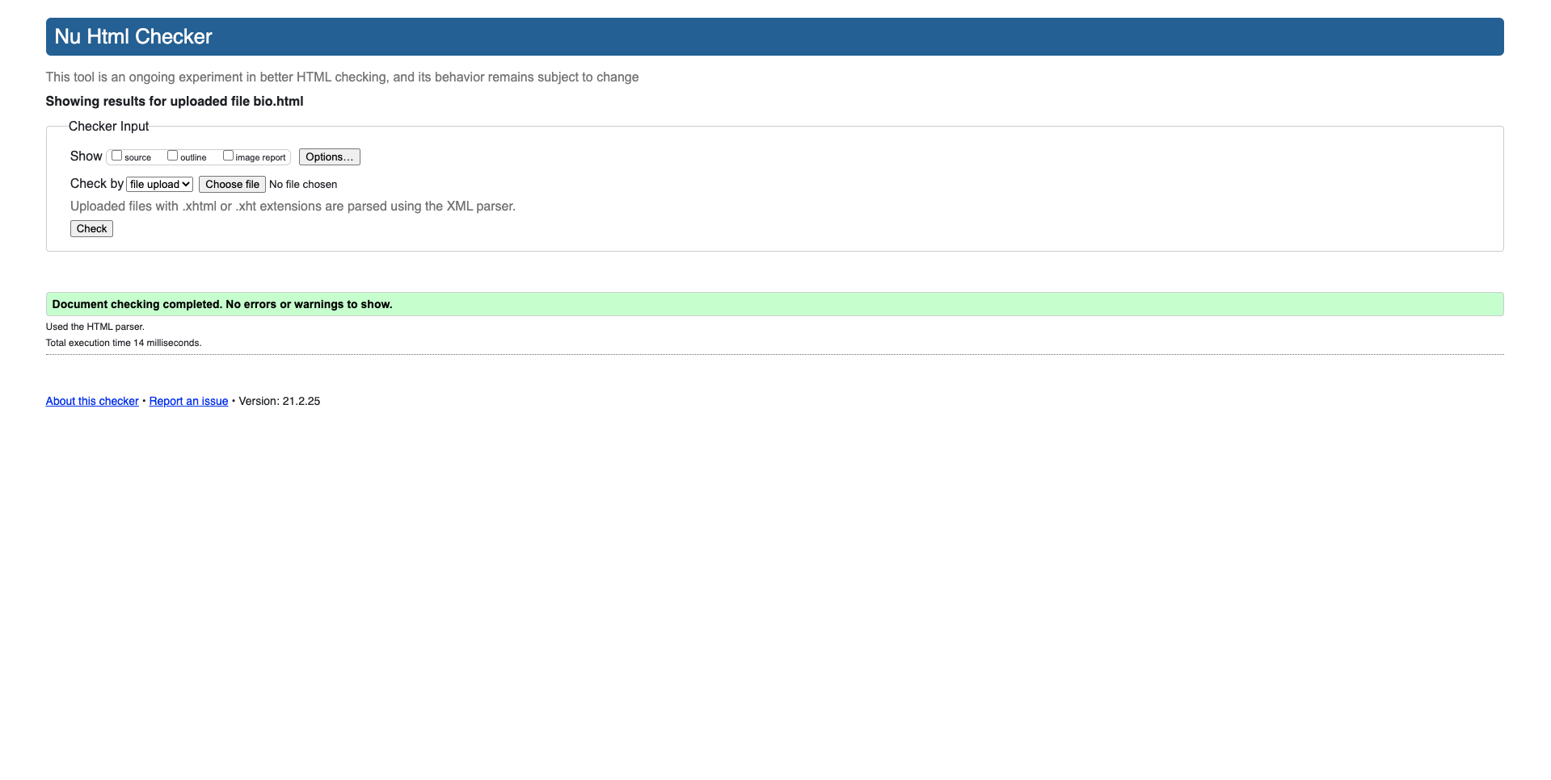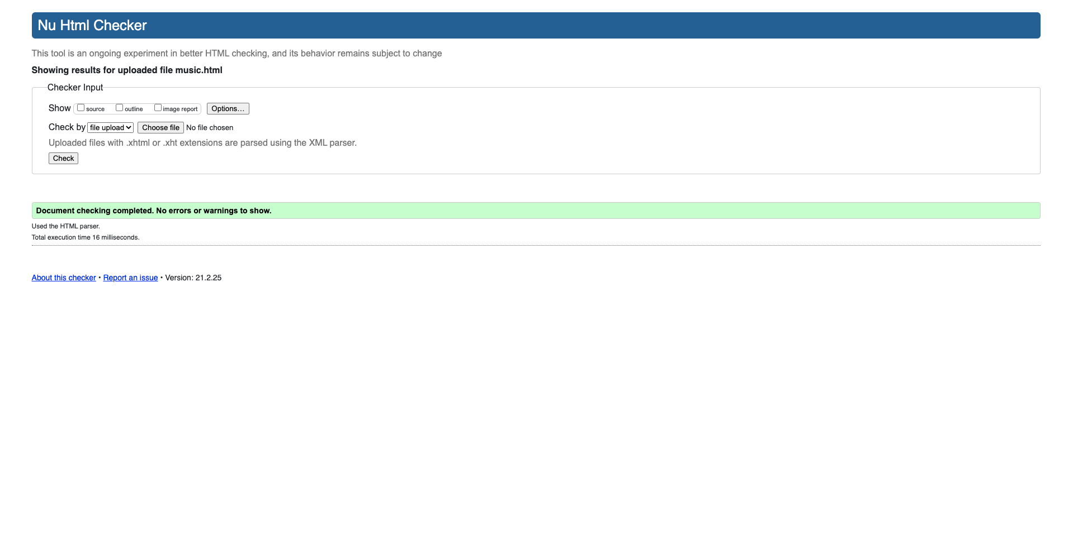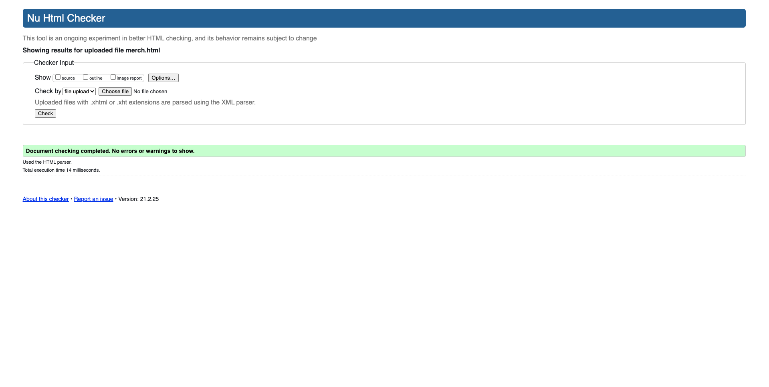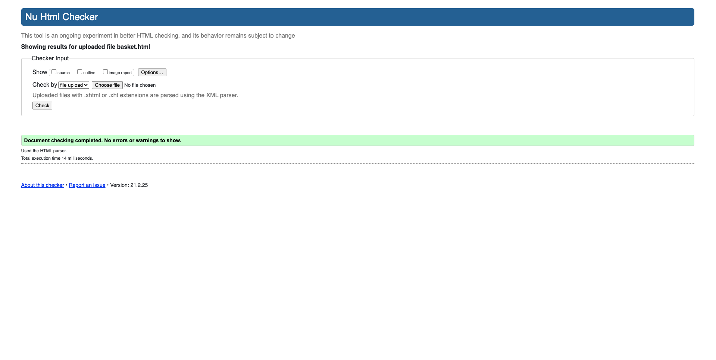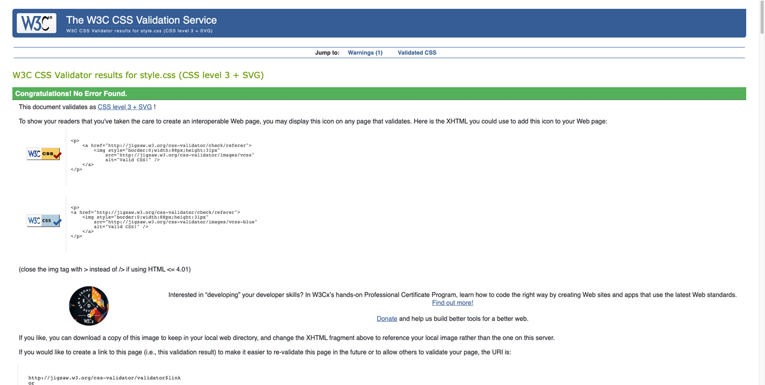

The evaluation of all the HTML pages came up with no errors so did the CSS evaluation.

4.3

To conclude, I feel really proud of the design, I believe it met the requirements and is visually and aesthetically pleasing. However, there are many elements I would like to have changed such as making the interactivity with the buttons seamless, implement more JavaScript to the website to add animations and make the pages dynamic. For CSS, I need to learn how to make classes responsive and how to create a grid layout.

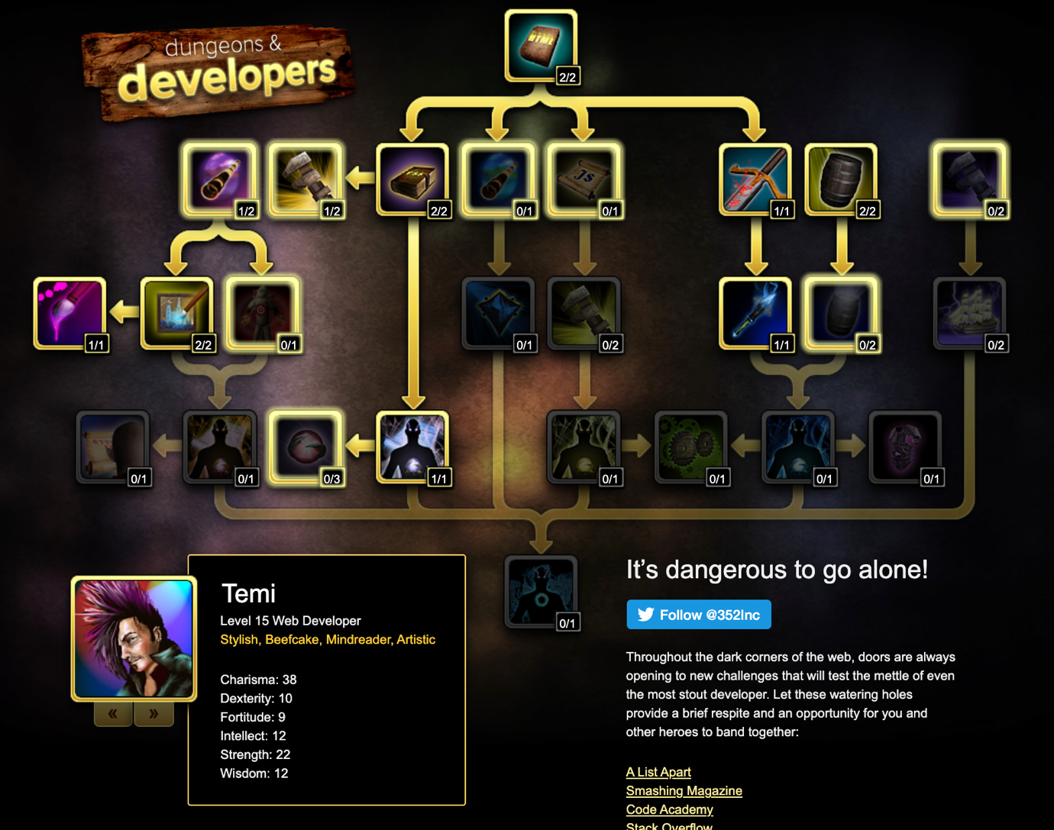

|  |  |
| --- | --- |
| **Reference** | |
|  | https://lnwy.co/read/under-the-covers-harry-israelson-the-art-of-toro-y-moi/ |
|  | http://www.undertheradarmag.com/news/toro_y_moi_shares_cover_of_joe_bataans_ordinary_guy_announces_instrumental_ |
|  | https://genius.com/albums/Toro-y-moi/Body-angles |
|  | https://pitchfork.com/reviews/albums/13931-causers-of-this/ |
|  | https://www.fiveriserecords.co.uk/product/toro-y-moi-underneath-the-pine/ |
|  | https://genius.com/albums/Toro-y-moi/Anything-in-return |
|  | https://pitchfork.com/reviews/albums/19977-les-sins-michael/ |
|  | https://pitchfork.com/reviews/albums/19977-les-sins-michael/ |
|  | https://pitchfork.com/reviews/albums/toro-y-moi-boo-boo/ |
|  | https://pitchfork.com/reviews/albums/23037-chaz-bundick-meets-the-mattson-2-star-stuff/ |
|  | https://toroymoi.bandcamp.com/album/freaking-out-ep |
|  | https://genius.com/albums/Toro-y-moi/Smartbeats |
|  | https://lessins.bandcamp.com/album/c-mon-les-go |
|  | https://www.gorillavsbear.net/toro-y-moi-drops-new-album-samantha-on-his-instagram/ |
| A blue t - shirt with white text on it  Description automatically generated with medium confidenceA brown t - shirt with text on it  Description automatically generated with medium confidenceA yellow t - shirt with a red logo on it  Description automatically generated with medium confidenceA blue t - shirt with white text on it  Description automatically generated with medium confidenceA white t - shirt with a message on it  Description automatically generated with low confidenceA t - shirt with a graphic design on it  Description automatically generated | https://store.toroymoi.com/ |
|  | https://www.iconfinder.com/ |